**Task 4**

1. #include <stdio.h>
2. int main() {
3. int marks, grade;
4. printf("Enter your marks:");
5. scanf("%d", &marks);
6. if(marks>=90)
7. {printf("Your grade is A");}
8. else if(marks<90 && marks>=80)
9. {printf("Your grade is B");}
10. else if(marks<80 && marks>=70)
11. {printf("Your grade is C");}
12. else if(marks<70 && marks>=60)
13. {printf("Your grade is D");}
14. else
15. {printf("Your grade is F");}
16. return 0;
17. }

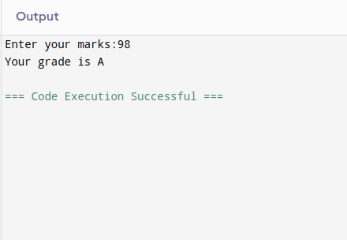

**TASK 5**

1. #include <stdio.h>
2. int main() {
3. int light_color;
4. printf("Enter your light color (1 for red, 2 for yellow, 3 for green) : ");
5. scanf("%d", &light_color);
6. switch (light_color)
7. {
8. case 1:
9. printf("stop");
10. break;
11. case 2:
12. printf("ready");
13. break;
14. case 3:
15. printf("go");
16. break;
17. }
19. return 0;
    1. }

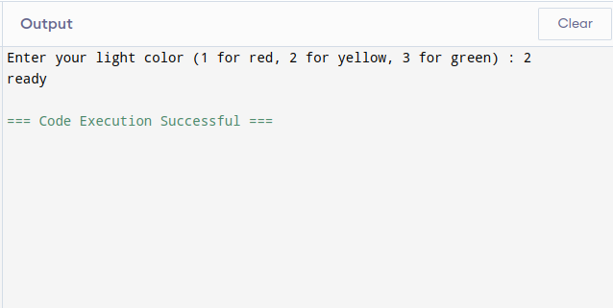

**TASK 6**

1. #include <stdio.h>
2. int main() {
3. int num1, num2, ans;
4. char operation;
5. printf("Enter number1 :");
6. scanf("%d", &num1);
7. printf("Enter number2 :");
8. scanf("%d", &num2);
9. printf("Enter operation (+._.*./) :");
10. scanf(" %c", &operation);
11. switch(operation){
12. case '+':
13. ans = num1 + num2;
14. printf("answer is :%d\n",ans);
15. break;
16. case '-':
17. ans = num1 - num2;
18. printf("answer is :%d\n",ans);
19. break;
21. case '*':
22. ans = num1 * num2;
23. printf("answer is :%d\n",ans);
24. break;
25. case '/':
26. ans = num1 / num2;
27. printf("answer is :%d\n",ans);
28. break;
29. }



34. return 0;
35. }

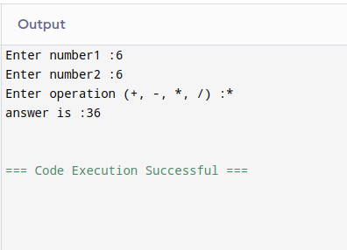

**Task 7**

1. #include <stdio.h>
2. int main()
3. {
4. int year;
5. printf("Enter year : ");
6. scanf("%d", &year);
7. if(year%4==0 && year%100!=0 || year%100!=0 && year%400==0)
8. {printf("it is a leap year");}
9. else
10. { printf("it is not a leap year");}
11. return 0;
12. }

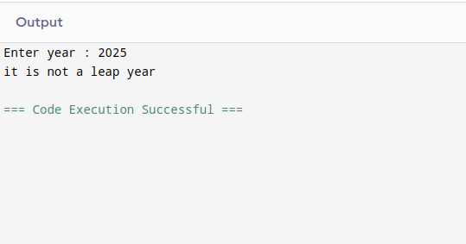

**Task 8**

1. #include <stdio.h>
2. int main()
3. {
4. int num;
5. printf("Enter the number : ");
6. scanf("%d", &num);
7. if(num>0)
8. {printf("It is a positive number");}
9. else if(num<0)
10. { printf("it is a negative number");}
11. else
12. {printf("it is zero");}
13. return 0;
14. }

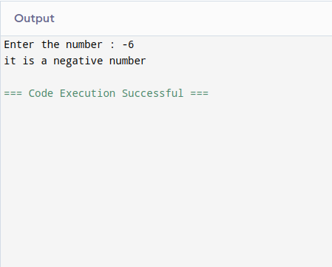

**Task 9**

1. #include <stdio.h>
2. int main()
3. {
4. int num;
5. printf("Enter the number : ");
6. scanf("%d", &num);
7. switch (num)
8. {
9. case 1:
10. printf("Monday");
11. break;
12. case 2:
13. printf("Tuesday");
14. break;
15. case 3:
16. printf("wednesday");
17. break;
18. case 4:
19. printf("Thrusday");
20. break;
21. case 5:
22. printf("Friday");
23. break;
24. case 6:
25. printf("Saturday");
26. break;
27. case 7:
28. printf("Sunday");
29. break;
30. default:
31. printf("invalid input!");
32. break;
33. }


37. return 0;
38. }

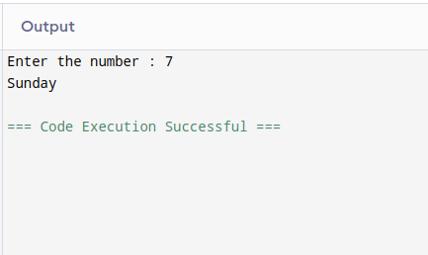

**Task 10**

1. #include <stdio.h>
2. int main()
3. {
4. int password;
5. int key_word = 00000;
6. printf("Enter your password : ");
7. scanf("%d", &password);
8. if (password == key_word)
9. {
10. printf("access granted!");}
11. else
12. {printf("access denied");
13. }



18. return 0;
19. }

